Deep Learning Lab

Submitted to: Submitted by:

logo |  | Name of university/college/institute
 |  | Subject Name: Deep Learning Lab |  | Subject Code:
 |  | Department: |  | Faculty Name:
S. NO. | Experiment Description |  | Experiment Number |  | Page No. | Remarks
1 | Creating a basic network and analyze its performance. |  |  |  | 3-5
2 | Deploy the Confusion matrix and simulate for Overfitting. |  |  |  | 6-7
3 | Visualizing a neural network. |  |  |  | 8-11
4 | Demo: Object Detection with pre-trained RetinaNet with Keras. |  |  |  | 12-14
5 | Neural Recommender Systems with Explicit Feedback. |  |  |  | 15-18
6 | Backpropagation in Neural Networks using Numpy. |  |  |  | 19-24
7 | Neural Recommender Systems with Implicit Feedback and the Triplet Loss. |  |  |  | 25-27
8 | Fully Convolutional Neural Networks. |  |  |  | 27-30
9 | ConvNets for Classification and Localization |  |  |  | 31-33
10 | Text Classification and Word Vectors. |  |  |  | 34-35
11 | Character Level Language Model (GPU required). |  |  |  | 36-38

 | Experiment Title: Creating a basic network and analyze its performance.
 | Laboratory: DEEP LEARNING LAB
Experiment No: 1 | Department: | Semester:

What are Neural Networks?
Neural networks are computational models inspired by the human brain. They’re designed to recognize patterns and solve complex problems. They are widely used in various fields, including image and speech recognition, natural language processing, and predictive analytics.
Importance of Neural Networks
- Pattern Recognition: Neural networks can identify complex patterns in large datasets, which makes them invaluable in fields like image and speech recognition.
- Automation: They can automate tasks that normally require human intervention, improving efficiency and reducing errors.
- Data-Driven Decisions: By analyzing vast amounts of data, neural networks help organizations make informed decisions based on insights gathered from their datasets.
- Adaptability: These models can learn and adapt over time and improve performance as they are exposed to more data.
- Real-Time Processing: Neural networks can process information in real time. This enables immediate responses in applications such as autonomous vehicles and fraud detection.
PROGRAM
import numpy as np
class NeuralNetwork:
def __init__(self, input_size, hidden_size, output_size, use_relu=False):
self.input_size = input_size
self.hidden_size = hidden_size
self.output_size = output_size
self.use_relu = use_relu
# Initialize weights and biases
self.W1 = np.random.randn(input_size, hidden_size) * 0.01
self.b1 = np.zeros((1, hidden_size))
self.W2 = np.random.randn(hidden_size, output_size) * 0.01
self.b2 = np.zeros((1, output_size))
# Activation functions
def sigmoid(self, x):
return 1 / (1 + np.exp(-x))
def sigmoid_derivative(self, x):
return x * (1 - )
def relu(self, x):
return np.maximum0, x)
def relu_derivative(self, x):
return (x > 0).astype(float)
def forward(self, X):
self.z1 = np.dot(X, self.W1) + self.b1
self.a1 = self.relu(self.z1) if self.use_relu else self.sigmoid(self.z1)
self.z2 = np.dot(self.a1, self.W2) + self.b2
self.output = self.sigmoid(self.z2)
return self.output
def backward(self, X, y, output, learning_rate):
# Output layer error and delta
self.output_error = y - output
self.output_delta = self.output_error * self.sigmoid_derivative(output)

# Hidden layer error and delta
self.a1_error = self.output_delta.dot(self.W2.T)
if self.use_relu:
self.a1_delta = self.a1_error * self.relu_derivative(self.a1)
else:
self.a1_delta = self.a1_error * self.sigmoid_derivative(self.a1)
# Update weights and biases
self.W2 += self.a1.T.dot(self.output_delta) * learning_rate
self.b2 += np.sum(self.output_delta, axis=0, keepdims=True) * learning_rate
self.W1 += X.T.dot(self.a1_delta) * learning_rate
self.b1 += np.sum(self.a1_delta, axis=0, keepdims=True) * learning_rate
def accuracy(self, y_true, y_pred):
predictions = (y_pred > 0.5).astype(int)
return np.mean(predictions == y_true)
def train(self, X, y, epochs, learning_rate, verbose=True):
for epoch in range(epochs):
output = self.forward(X)
self.backward(X, y, output, learning_rate)
if verbose and (epoch + 1) % 100 == 0:
loss = np.mean(np.square(y - output))
acc = self.accuracy(y, output)
print(f"Epoch {epoch+1}, Loss: {loss:.4f}, Accuracy: {acc:.4f}")
def predict(self, X):
return self.forward(X)
# Define input and output data
X = np.array([[0, 0], [0, 1], [1, 0], [1, 1]])
y = np.array([[0], [1], [1], [0]]) # XOR problem
# Initialize and train the network
nn = NeuralNetwork(input_size=2, hidden_size=4, output_size=1, use_relu=True)
nn.train(X, y, epochs=5000, learning_rate=0.1)
# Make predictions and evaluate performance
predictions = nn.predict(X)
print("\nPredictions:")
print(predictions.round()) # Round to 0 or 1 for binary classification
# Calculate accuracy
accuracy = np.mean((predictions.round() == y).astype(float))
print(f"Accuracy: {accuracy:.2f}")
# Calculate Mean Squared Error
mse = np.mean(np.square(y - predictions))
print(f"Mean Squared Error: {mse:.4f}")

OUTPUT

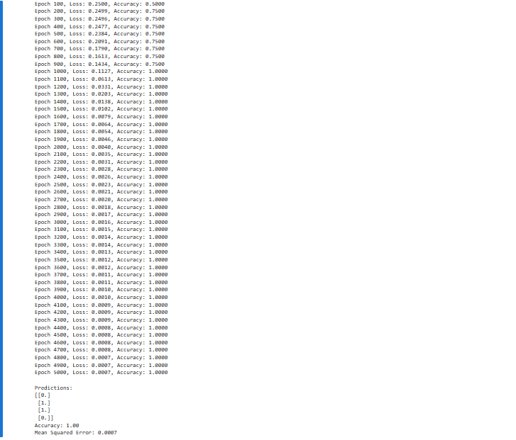
 | Experiment Title: Deploy the Confusion matrix and simulate for Overfitting.
 | Laboratory: DEEP LEARNING LAB
Experiment No: 2 | Department: | Semester:

Understanding the Confusion Matrix
Confusion matrix is a simple table used to measure how well a classification model is performing. It compares the predictions made by the model with the actual results and shows where the model was right or wrong. This helps you understand where the model is making mistakes so you can improve it. It breaks down the predictions into four categories:
- True Positive (TP): The model correctly predicted a positive outcome i.e. the actual outcome was positive.
- True Negative (TN): The model correctly predicted a negative outcome i.e. the actual outcome was negative.
- False Positive (FP): The model incorrectly predicted a positive outcome i.e. the actual outcome was negative. It is also known as a Type I error.
- False Negative (FN): The model incorrectly predicted a negative outcome i.e. the actual outcome was positive. It is also known as a Type II error.

PROGAM
import tensorflow as tf
from tensorflow.keras.datasets import mnist
from tensorflow.keras.models import Sequential
from tensorflow.keras.layers import Conv2D, MaxPooling2D, Flatten, Dense
from sklearn.metrics import confusion_matrix, ConfusionMatrixDisplay
import matplotlib.pyplot as plt
import numpy as np
# Load dataset
(x_train, y_train), (x_test, y_test) = mnist.load_data()
x_train = x_train.reshape(-1, 28, 28, 1) / 255.0
x_test = x_test.reshape(-1, 28, 28, 1) / 255.0
# Build model
model = Sequential([
Conv2D(32, (3,3), activation='relu', input_shape=(28,28,1)),
MaxPooling2D((2,2)),
Flatten(),
Dense(128, activation='relu'),
Dense(10, activation='softmax')
])

model.compile(optimizer='adam', loss='sparse_categorical_crossentropy', metrics=['accuracy'])
# Train model with excessive epochs to simulate overfitting
history = model.fit(x_train, y_train, epochs=20, validation_data=(x_test, y_test))
# Predict and generate confusion matrix
y_pred = np.argmax(model.predict(x_test), axis=1)
cm = confusion_matrix(y_test, y_pred)
disp = ConfusionMatrixDisplay(confusion_matrix=cm)
disp.plot()
plt.title("Confusion Matrix")
plt.show()
# Plot training vs validation accuracy
plt.plot(history.history['accuracy'], label='Training Accuracy')
plt.plot(history.history['val_accuracy'], label='Validation Accuracy')
plt.title("Overfitting Simulation")
plt.xlabel("Epochs")
plt.ylabel("Accuracy")
plt.legend()
plt.show()

OUTPUT:

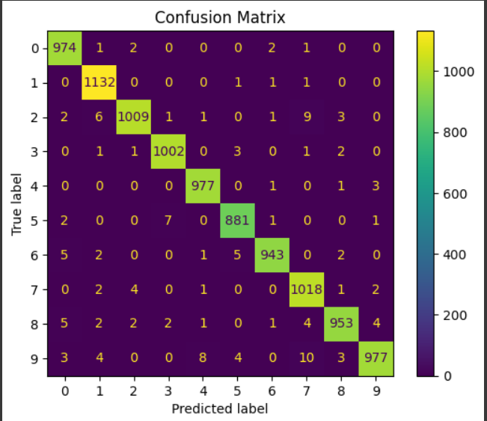
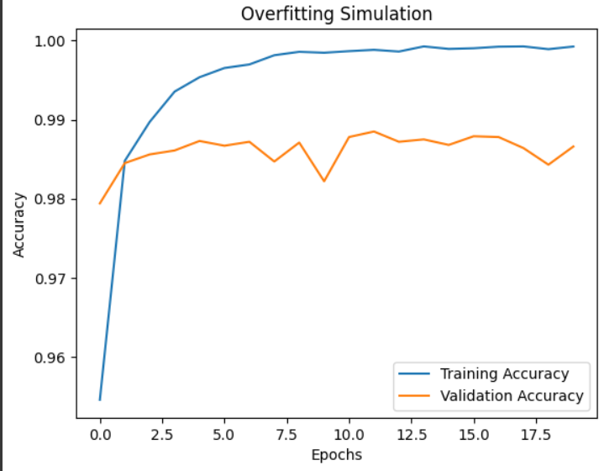

 | Experiment Title: Visualizing a neural network.
 | Laboratory: DEEP LEARNING LAB
Experiment No: 3 | Department: | Semester:

Introduction

Neural network is an information-processing machine and can be viewed as analogous to human nervous system. Just like human nervous system, which is made up of interconnected neurons, a neural network is made up of interconnected information processing units. The information processing units do not work in a linear manner. In fact, neural network draws its strength from parallel processing of information, which allows it to deal with non-linearity. Neural network becomes handy to infer meaning and detect patterns from complex data sets.

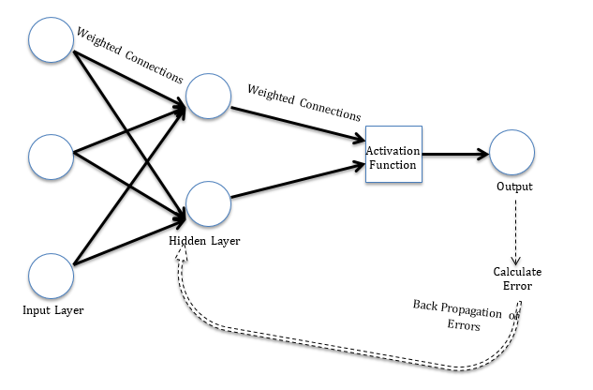
Figure 1 Neural Network

Neural network terms

Neural networks consist of three layers of nodes:
- Input layer: This is the first layer of the neural network which passes the information to subsequent layers without performing any computational tasks.
- Hidden layer: This consists of one or more layers and acts as the connection between the input and output layer. These layers perform all the computational work.
- Output layer: This layer is responsible for transferring the data to the outside world.
Each layer can have one or many nodes. The neural network having multiple hidden layers with one or more neurons is called a ‘Deep Neural Network’. This type of model is used in various applications of machine learning such as machine translation, image processing, speech recognition, image recognition, etc.
- Epoch: An epoch is one complete cycle when the entire dataset is passed forward and backward through the neural network once.
- Learning rate: Learning rate is a configurable hyper parameter (the properties/parameters that govern the whole Neural Network training visualization process) used in the training of neural networks that has a small positive value. The learning rate ranges from 0.00001 to 10 in the Tensorflow playground. It controls how quickly the model is adapted to the problem. Smaller learning rates require more training epochs given the smaller changes made to the weights each update, whereas larger learning rates result in rapid changes and require fewer training epochs.
- Activation function: This is the function in an artificial neuron that delivers an output based on inputs. ReLU, Tanh, Sigmoid, and Linear are some available activation functions in the Tensorflow playground. The output of each function is used as an input in the next function in each epoch until we get the desired solution.
- Regularization rate: This is a technique used for tuning the activation function by adding an additional penalty term in the error function. The value of the regularization rate varies from 0 to 10 in the Tensorflow playground.
- Problem type: Problem type is broadly classified into two parts: classification and regression. Classification problems are those problems that have categorical output, e.g., an artificial neural network used to identify dog vs cat. In these scenarios, the output is either of the two categories, i.e cat or dog. In regression problems, the output is a numerical value ranging from starting and ending point (e.g., an artificial neural network used to identify dog vs cat, the output can also be shaped as a percentage match as dog or cat. In this scenario, the output lies between 0–100).
- The ratio of the training and testing sets: Every given dataset is divided into categories: testing and training sets. The training set is the set of data that is used to train the neural network to get the desired output. The testing set is the set of data that is used to test the model prediction capability, on an unseen data set. We usually set that ratio to 70/30 or 80/20.
- Noise: Noise is a distortion in data, that is unwanted by the perceiver of data. Adding noise to inputs is like telling the network to not change the output in a ball around your exact input.
- Batch size: This refers to the number of training examples or data points utilized in one epoch. For example, the batch size is usually between 10 and 1000. Batch size is usually fixed during training and inference; however, the TensorFlow Playground does permit dynamic batch sizes.
- Features: Features are the properties of the node or neuron that we want to feed in during the artificial neural network generation. There are a number of properties to choose from in the Tensorflow Playground.
- Hidden layer: These are layers that are located between the input and output layer, in which the function applies different weights to the inputs and directs through an activation function as the output. There can be one or many hidden layers with one or many nodes attached to it.
- Output layer: This is the last layer in the artificial neural network generation that produces the output of neural nets.
PROGRAM
# Step 1: Install required packages (only needed once)
!pip install pydot
!apt-get install graphviz
# Step 2: Import libraries
import tensorflow as tf
from tensorflow.keras.models import Sequential
from tensorflow.keras.layers import Input, Conv2D, MaxPooling2D, Flatten, Dense
from tensorflow.keras.utils import plot_model
# Step 3: Build CNN model using Input() layer
model = Sequential([
Input(shape=(28, 28, 1)), # Input layer for grayscale images
Conv2D(32, (3, 3), activation='relu'), # Convolutional layer
MaxPooling2D((2, 2)), # Pooling layer
Flatten(), # Flatten layer
Dense(128, activation='relu'), # Hidden dense layer
Dense(10, activation='softmax') # Output layer for 10 classes
])
# Step 4: Display model summary
model.summary()
# Step 5: Visualize and save model architecture
plot_model(model, to_file='cnn_model.png', show_shapes=True, show_layer_names=True)
# Step 6: Display the image in Colab
from IPython.display import Image
Image(filename='cnn_model.png')

OUTPUT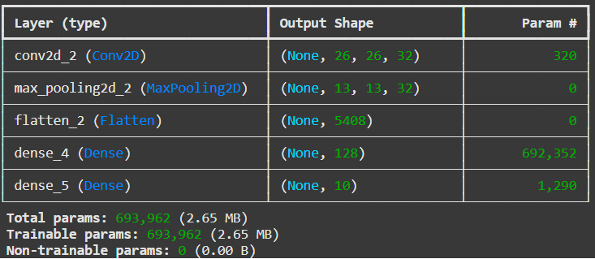
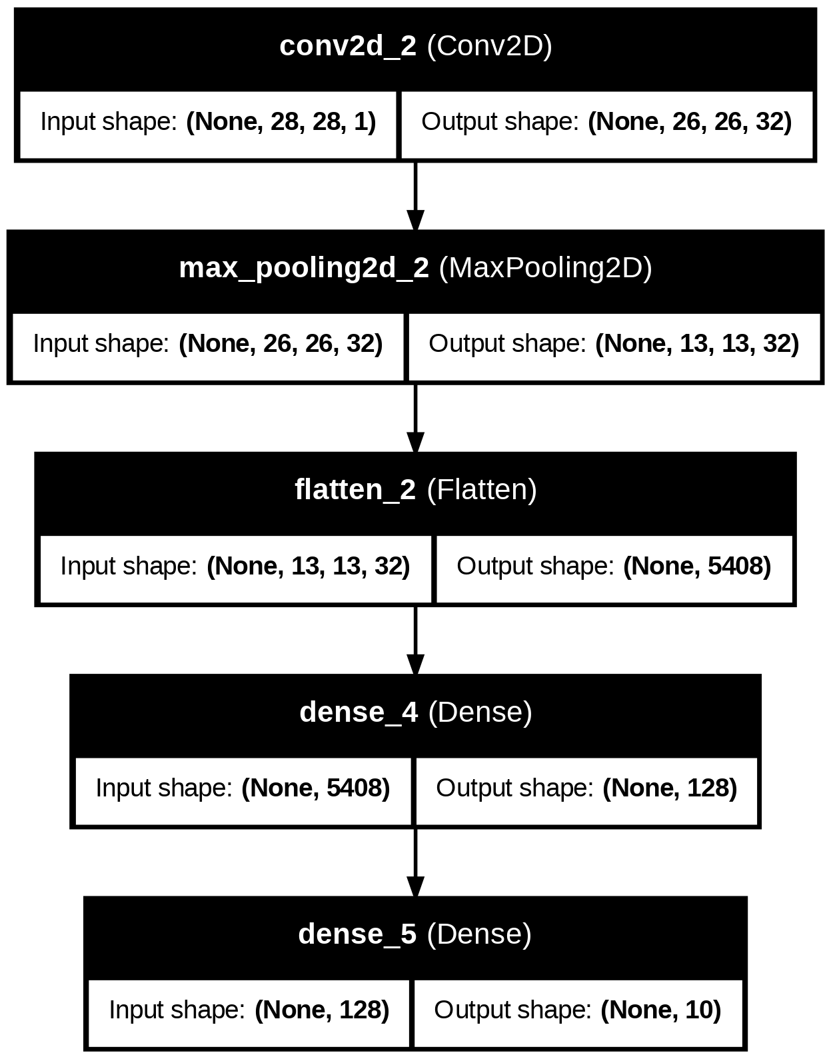

 | Experiment Title: Demo: Object Detection with pre-trained RetinaNet with Keras.
 | Laboratory: DEEP LEARNING LAB
Experiment No: 4 | Department: | Semester:

Introduction
RetinaNet is one of the best one-stage object detection models that has proven to work well with dense and small scale objects. For this reason, it has become a popular object detection model to be used with aerial and satellite imagery.
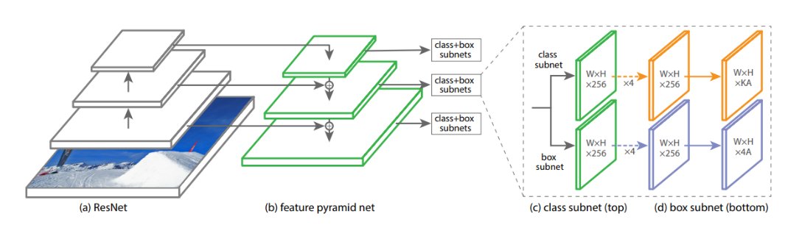
Figure 2 RetinaNet

PROGRAM

# plot one photograph and mask
from os import listdir
from xml.etree import ElementTree
from numpy import zeros
from numpy import asaray
from mrean.utils import Dataset
from matplotlib import pyplot

# class that defines and loads the kangaroo dataset
class KangarooDataset(Dataset):
# load the dataset defiitions
def load_dataset(self, dataset_dir, is_traim"True):
# define one class
selfadd_class("dataset", 1, "kangaroo")
# define data locations
images_dir= dataset_dir + "Vimages"
annotations_dir= dataset_dir +'Vannots"
# find all images
for filemame in listdinimages_dir)
# extract image id
image_id= filename[ :- 4]
# skip had images
if image_id in ['0000']:
continue
#skip all images after 150 if we are building the train set
if is_traim and ino[image_id) >= 150
continue
# skip all images hefore 150 if we are building the test/val set
if not is_train and int(image_id) < 150:
continue
img path = images dir+ filename
ann_path = ammotations_dir+ image_id+'xmml
# add to dataset
self.add_image['dataser, image_id=image_id, path=img_path, annotation=amm_path)
# extract bounding hoxes from an annotation file
def extract_boxes(self, filemame):
# load and parse the file
tree = ElementTree.parse[filename)
# get the root of the documemt
root=tree getrocs
# extract each bounding box
boxes = list()
for box in root.findall("//bndhox"):
ymim= imn(box.find('ymin').text)
xmax=int(box.find['xmax').text)
ymax= imt(box.find['ymax').text)
coors = [xmin, ymin, xmax, ymax]
boxes.append(coors)
# extract image dimensions
width= inn(root.find(("'./size/width').text)
height= introot.find(".Nsize/height).text)
retum boxes, width, height33
# load the masks for an image
def load_mask[self, image_id)
#get details of image
imfo=self.image_info[umage_id]
# define box file location
path = info['annotation"]
# load XML
boxes, w, h = self.extract_boxes[path)
# create one aray for all masks, each on a different channel
masks = zerosi[h, w, lem(boxes)], dtype-'uint8)
# create masks
class_ids = list)
for i in range(len(boxes)):
box = boxesi]
wow_s.wow_e=box[1], box[3]
col_s, col_e= hox[0], box[2]
masks[row_s.row_e.col_sxol_e, ij=1
class_ids.append(self.class_names.index(kangaroo"))
retm masks, asarray(class_ids, dtype="imt32')

# load an image reference
del'image_reference(self, image_id):
imfo=self.image_info[image_id]
retm info['path']
# train set
train_set= KangarooDataset()
train_set.load_dataset(kangaroo', is_train=True)
train_set.prepare()
# load an image
image_id=0
image= train_set.load_image[image_id)
print[image.shape)
# load image mask
mask, class_ids= train_set.load_maskimage_id)
print[mask.shape)
# plot image
pyplot.imshow[image)
# plot mask
pyplot.immshow[mask[:, :, 0], cmap"gray', alpha=0.5)
pyplot.show()

OUTPUT

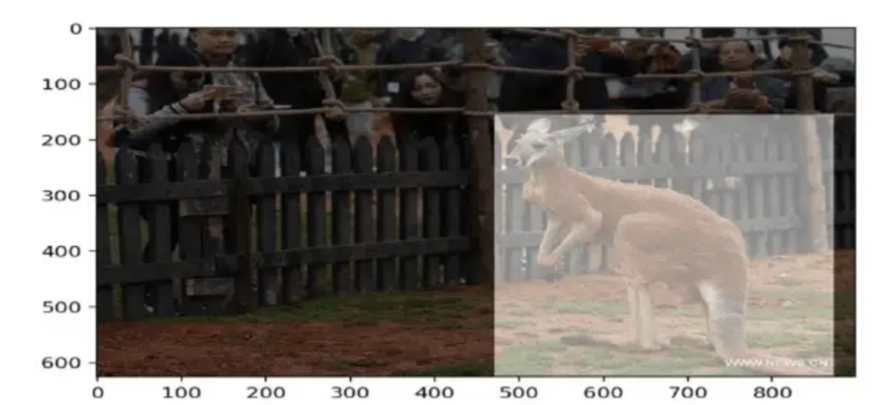

 | Experiment Title: Neural Recommender Systems with Explicit Feedback.
 | Laboratory: DEEP LEARNING LAB
Experiment No: 5 | Department: | Semester:

What Are Neural Recommender Systems?
Neural Recommender Systems (NRS) use deep learning models (neural networks) to predict user preferences and generate recommendations. They replace or extend classical methods like Matrix Factorization (MF) and Collaborative Filtering (CF) with neural architectures that can model nonlinear, high-dimensional, and context-dependent relationships.
PROGRAM
# Neural Recommender System (Explicit Feedback)
# Dataset: MovieLens 100K
# Framework: PyTorch
#Step 1: Import libraries
import torch
import torch.nn as nn
import torch.optim as optim
from torch.utils.data import Dataset, DataLoader
import pandas as pd
import numpy as np
from sklearn.model_selection import train_test_split
import os
# Step 2: Load the MovieLens 100K dataset
# Correct path for Kaggle
path = "/kaggle/input/movielens-100k-dataset/ml-100k"
# Check files
print("Available files:", os.listdir(path))
# Load u.data
df = pd.read_csv(os.path.join(path, "u.data"),
sep="\t",
names=["user_id", "item_id", "rating", "timestamp"])
# Drop timestamp
df = df.drop("timestamp", axis=1)
# Reindex users and items from 0
df["user_id"] -= 1
df["item_id"] -= 1
print(df.head())
print(f"Total ratings: {len(df)}, Unique users: {df.user_id.nunique()}, Unique items: {df.item_id.nunique()}")
# Step 3: Split into train/test
train_df, test_df = train_test_split(df, test_size=0.2, random_state=42)
num_users = df["user_id"].nunique()
num_items = df["item_id"].nunique()
# Step 4: Define Dataset class
class RatingDataset(Dataset):
def __init__(self, df):
self.users = torch.tensor(df["user_id"].values, dtype=torch.long)
self.items = torch.tensor(df["item_id"].values, dtype=torch.long)
self.ratings = torch.tensor(df["rating"].values, dtype=torch.float32)
def __len__(self):
return len(self.ratings)
def __getitem__(self, idx):
return self.users[idx], self.items[idx], self.ratings[idx]
train_data = RatingDataset(train_df)
test_data = RatingDataset(test_df)
train_loader = DataLoader(train_data, batch_size=128, shuffle=True)
test_loader = DataLoader(test_data, batch_size=128)
# Step 5: Define Neural Matrix Factorization (NeuMF) model
class NeuralMF(nn.Module):
def __init__(self, num_users, num_items, embedding_dim=32, hidden_dim=64):
super().__init__()
# Embeddings
self.user_emb = nn.Embedding(num_users, embedding_dim)
self.item_emb = nn.Embedding(num_items, embedding_dim)
# MLP layers
self.mlp = nn.Sequential(
nn.Linear(embedding_dim*2, hidden_dim),
nn.ReLU(),
nn.Linear(hidden_dim, hidden_dim//2),
nn.ReLU(),
nn.Linear(hidden_dim//2, 1)
)
# Initialize embeddings
nn.init.normal_(self.user_emb.weight, std=0.01)
nn.init.normal_(self.item_emb.weight, std=0.01)
def forward(self, user, item):
u = self.user_emb(user)
i = self.item_emb(item)
x = torch.cat([u, i], dim=-1)
rating = self.mlp(x)
return rating.squeeze()
# Step 6: Initialize model, loss, optimizer
device = torch.device("cuda" if torch.cuda.is_available() else "cpu")
print("Using device:", device)
model = NeuralMF(num_users, num_items, embedding_dim=32, hidden_dim=64).to(device)
criterion = nn.MSELoss()
optimizer = optim.Adam(model.parameters(), lr=0.001)
# Step 7: Train the model
epochs = 10
for epoch in range(epochs):
model.train()
total_loss = 0
for users, items, ratings in train_loader:
users, items, ratings = users.to(device), items.to(device), ratings.to(device)
optimizer.zero_grad()
preds = model(users, items)
loss = criterion(preds, ratings)
loss.backward()
optimizer.step()
total_loss += loss.item()
avg_loss = total_loss / len(train_loader)
print(f"Epoch {epoch+1}/{epochs} | Training Loss: {avg_loss:.4f}")
# Step 8: Evaluate the model (RMSE)
model.eval()
preds, truths = [], []
with torch.no_grad():
for users, items, ratings in test_loader:
users, items, ratings = users.to(device), items.to(device), ratings.to(device)
outputs = model(users, items)
preds.extend(outputs.cpu().numpy())
truths.extend(ratings.cpu().numpy())
preds = np.clip(preds, 1, 5) # Clip predictions to valid rating range
rmse = np.sqrt(np.mean((np.array(preds) - np.array(truths))**2))
print(f"\n Test RMSE: {rmse:.4f}")

OUTPUT
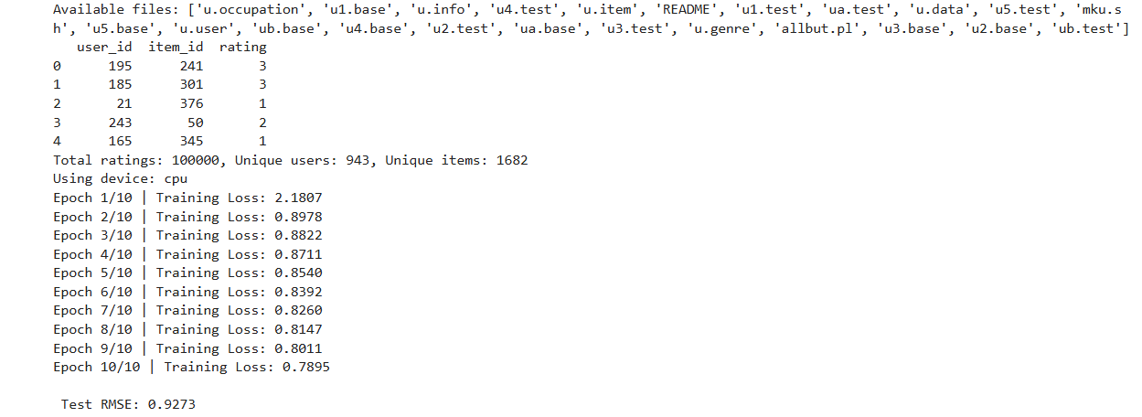

 | Experiment Title: Backpropagation in Neural Networks using Numpy.
 | Laboratory: DEEP LEARNING LAB
Experiment No: 6 | Department: | Semester:

Backpropagation in Neural Network
Backpropagation, short for Backward Propagation of Errors, is a key algorithm used to train neural networks by minimizing the difference between predicted and actual outputs. It works by propagating errors backward through the network, using the chain rule of calculus to compute gradients and then iteratively updating the weights and biases. Combined with optimization techniques like gradient descent, backpropagation enables the model to reduce loss across epochs and effectively learn complex patterns from data.
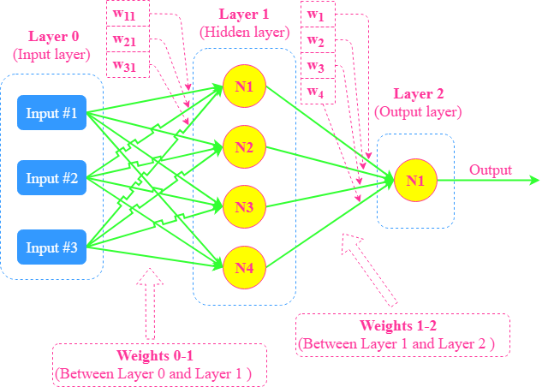Core Steps of Backpropagation with NumPy:
Forward Pass:
- Compute the weighted sum of inputs and biases for each layer (linear transformation).
- Apply the activation function to the linear output to get the activations for each layer.
- Propagate these activations through the network until the final output layer.
- Calculate the loss between the network's predicted output and the actual target output.
Backward Pass (Backpropagation):
- Output Layer Gradient: Calculate the gradient of the loss with respect to the output layer's pre-activations (the linear output before the activation function). This involves the derivative of the loss function and the derivative of the output layer's activation function.
- Output Layer Weight and Bias Gradients: Use the output layer gradient to compute the gradients of the loss with respect to the weights and biases of the output layer.
- Hidden Layer Gradients: Propagate the gradients backward through the network, layer by layer. For each hidden layer, calculate the gradient of the loss with respect to its activations, then its pre-activations, and finally its weights and biases. This involves applying the chain rule of calculus and using the derivatives of the activation functions.
- NumPy Operations: Utilize NumPy's array operations for efficient matrix multiplications (e.g., np.dot), element-wise operations, and broadcasting to perform these gradient calculations.
PROGRAM
# Creating a three layers NN by using mathematical 'numpy' library
# Using methods from the library to operate with matrices

# Importing 'numpy' library
import numpy as np
# Importing 'matplotlib' library to plot experimental results in form of figures
import matplotlib.pyplot as plt

# Creating a class for three layers Neural Network
class ThreeLayersNeuralNetwork():
def __init__(self):
# Using 'seed' for the random generator
# It'll return the same random numbers each time the program runs
# Very useful for debugging
np.random.seed(1)

# Modeling three layers Neural Network
# Input layer (Layer 0) has three parameters
# Hidden layer (Layer 1) has four neurons
# Output layer (Layer 2) has one neuron
# Initializing weights between input and hidden layers
# The values of the weights are in range from -1 to 1
# We receive matrix 3x4 of weights (3 inputs in Layer 0 and 4 neurons in Layer 1)
self.weights_0_1 = 2 * np.random.random((3, 4)) - 1

# Initializing weights between hidden and output layers
# The values of the weights are in range from -1 to 1
# We receive matrix 4x1 of weights (4 neurons in Layer 1 and 1 neuron in Layer 2)
self.weights_1_2 = 2 * np.random.random((4, 1)) - 1

# Creating a variable for storing matrix with output results
self.layer_2 = np.array([])

# Creating function for normalizing weights and other results by Sigmoid curve
def normalizing_results(self, x):
return 1 / (1 + np.exp(-x))

# Creating function for calculating a derivative of Sigmoid function (gradient of Sigmoid curve)
# Which is going to be used for back propagation - correction of the weights
# This derivative shows how good is the current weights
def derivative_of_sigmoid(self, x):
return x * (1 - x)

# Creating function for running and testing NN after training
def run_nn(self, set_of_inputs):
# Feed forward through three layers in NN
# Results are returned in normalized form in appropriate dimensions
layer_0 = set_of_inputs # matrix 1x3
layer_1 = self.normalizing_results(np.dot(layer_0, self.weights_0_1)) # matrix 1x3 * matrix 3x4 = matrix 1x4
layer_2 = self.normalizing_results(np.dot(layer_1, self.weights_1_2)) # matrix 1x4 * matrix 4x1 = matrix 1x1
return layer_2

# Creating function for training the NN
def training_process(self, set_of_inputs_for_training, set_of_outputs_for_training, iterations):
# Training NN desired number of times
for i in range(iterations):
# Feeding our NN with training set and calculating output
# Feed forward through three layers in NN
# With 'numpy' library and function 'dot' we multiply matrices with values in layers to appropriate weights
# Results are returned in normalized form in appropriate dimensions
layer_0 = set_of_inputs_for_training # matrix 4x3
layer_1 = self.normalizing_results(np.dot(layer_0, self.weights_0_1)) # matrix 4x3 * matrix 3x4 = matrix 4x4
self.layer_2 = self.normalizing_results(np.dot(layer_1, self.weights_1_2)) # matrix 4x4 * matrix 4x1 = matrix 4x1

# Using Backpropagation for calculating values to correct weights
# Calculating an error for output layer (Layer 2) which is the difference between desired output and obtained output
# We subtract matrix 4x1 of received outputs from matrix 4x1 of desired outputs
layer_2_error = set_of_outputs_for_training - self.layer_2

# Showing the error each 500 iterations to track the improvements
# Comment before analysis to prevent extra information to be shown
if (i % 500) == 0:
print('Final error after', i, 'iterations =', np.mean(np.abs(layer_2_error)

# Calculating delta for output layer (Layer 2)
# Using sign '*' instead of function 'dot' of numpy library
# In this way matrix 4x1 will be multiplied by matrix 4x1 element by element
# For example,
# n = np.array([[1], [1], [1], [1]])
# m = np.array([[2], [3], [4], [5]])
# n * m = [[2], [3], [4], [5]]
# That is what we need now for this case
delta_2 = layer_2_error * self.derivative_of_sigmoid(self.layer_2)

# Calculating an error for hidden layer (Layer 1)
# Multiplying delta_2 by weights between hidden layer and output layer
# Shows us how much hidden layer (Layer 1) influences on to the layer_2_error
layer_1_error = np.dot(delta_2, self.weights_1_2.T)

# Calculating delta for hidden layer (Layer 1)
delta_1 = layer_1_error * self.derivative_of_sigmoid(layer_1)

# Implementing corrections of weights
self.weights_1_2 += np.dot(layer_1.T, delta_2)
self.weights_0_1 += np.dot(layer_0.T, delta_1)

# Creating three layers NN by initializing of instance of the class
three_layers_neural_network = ThreeLayersNeuralNetwork()

# Showing the weights of synapses initialized from the very beginning randomly
# Weights 0-1 between input layer (Layer 0) and hidden layer (Layer 1)
print('Weights 0-1')
print(three_layers_neural_network.weights_0_1)
print()

# Weights 1-2 between hidden layer (Layer 1) and output layer (Layer 2)
print('Weights 1-2')
print(three_layers_neural_network.weights_1_2)
print()
# [[-0.5910955 ]
# [ 0.75623487]
# [-0.94522481]
# [ 0.34093502]]

# Creating a set of inputs and outputs for the training process
# Using function 'array' of the 'numpy' library
# Creating matrix 4x3
input_set_for_training = np.array([[1, 1, 1], [1, 0, 1], [0, 0, 1], [0, 1, 1]])
# Create matrix 1x4 and transpose it to matrix 4x1 at the same time
output_set_for_training = np.array([[1, 1, 0, 0]]).T

# Showing the output results after training
print()
print('Output results after training:')
print(three_layers_neural_network.layer_2)
print()
print('Output result for testing data = ', three_layers_neural_network.run_nn(np.array([1, 0, 0])))

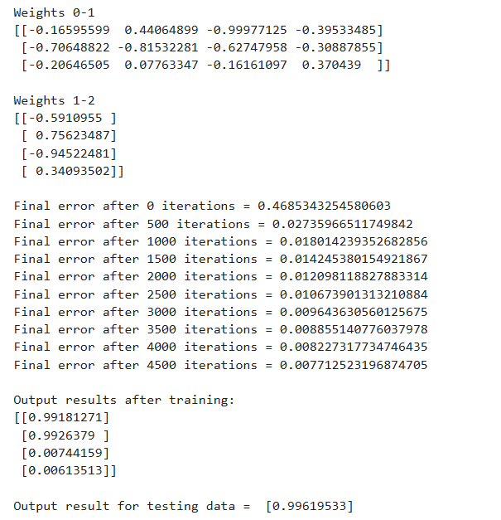

Analysis of results
# Analysis of results
# It is better to comment two lines in the class 'ThreeLayersNeuralNetwork' before analysis:
if (i % 500) == 0:
print('Final error after', i, 'iterations =', np.mean(np.abs(layer_2_error)))
'''
# In order not to show extra information

# Finding needed amount of iterations to reach curtain accuracy
# Creating list to store the resulting data
lst_result = []

# Creating list to store the number of iterations for each experiment
lst_iterations = []

# Creating a loop and collecting resulted output data with different numbers of iterations
# From 10 to 1000 with step=10
for i in range(10, 1000, 10):
# Creating new instance of the NN class each time
# In order not to be influenced from the previous training results
three_layers_neural_network_analysis = ThreeLayersNeuralNetwork()

# Starting the training process with number of repetitions equals to i
three_layers_neural_network_analysis.training_process(input_set_for_training, output_set_for_training, i)

# Collecting number of iterations in the list
lst_iterations += [i]

# Now we run trained NN with data for testing and obtain the result
output = three_layers_neural_network_analysis.run_nn(np.array([1, 0, 0]))

# Collecting resulted outputs in the list
lst_result += [output]

# Plotting the results
plt.figure()
plt.plot(lst_iterations, lst_result, 'b')
plt.title('Iterations via Output')
plt.xlabel('Iterations')
plt.ylabel('Output')

# Showing the plot
plt.show()

# Find exact number of iterations in order to reach specific accuracy
i = 10 # Iterations
output = 0.1 # Output
# Creating a while loop and training NN
# Stop when output reached accuracy 0.99
while output < 0.99:
# Creating new instance of the NN class each time
# In order not to be influenced from the previous training results above
three_layers_neural_network_analysis_1 = ThreeLayersNeuralNetwork()

# Starting the training process with number of repetitions equals to i
three_layers_neural_network_analysis_1.training_process(input_set_for_training, output_set_for_training, i)

# Now we run trained NN with data for testing and obtain the result
output = three_layers_neural_network_analysis_1.run_nn(np.array([1, 0, 0]))

# Increasing the number of iterations
i += 10

# Showing the found number of iterations for accuracy 0.99
print()
print('Number of iterations to reach accuracy 0.99 is', i) # Needed numbers of iterations is equal to 1010

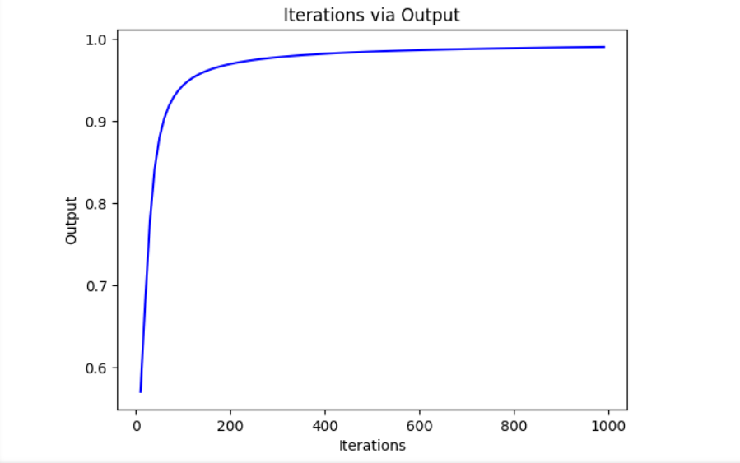

 | Experiment Title: Neural Recommender Systems with Implicit Feedback and the Triplet Loss.
 | Laboratory: DEEP LEARNING LAB
Experiment No: 7 | Department: | Semester:

PROGRAM
#Neural Recommender System (Implicit Feedback + Triplet Loss)
# Dataset: MovieLens 100K
# Framework: PyTorch
import torch
import torch.nn as nn
import torch.optim as optim
from torch.utils.data import Dataset, DataLoader
import pandas as pd
import numpy as np
import random
import os

# Step 1: Load dataset
path = "/kaggle/input/movielens-100k-dataset/ml-100k"
df = pd.read_csv(os.path.join(path, "u.data"), sep="\t",
names=["user_id", "item_id", "rating", "timestamp"])
df["user_id"] -= 1
df["item_id"] -= 1
# Convert to implicit feedback
df["interaction"] = 1
num_users = df["user_id"].nunique()
num_items = df["item_id"].nunique()
print(f"Users: {num_users}, Items: {num_items}, Interactions: {len(df)}")

# Step 2: Create triplets
class TripletDataset(Dataset):
def __init__(self, df, num_items):
self.df = df
self.num_items = num_items
self.user_pos_items = self._get_user_pos_items()
def _get_user_pos_items(self):
user_pos = {}
for u, i in zip(self.df.user_id, self.df.item_id):
if u not in user_pos:
user_pos[u] = set()
user_pos[u].add(i)
return user_pos
def __len__(self):
return len(self.df)
def __getitem__(self, idx):
user = self.df.iloc[idx]["user_id"]
pos_item = self.df.iloc[idx]["item_id"]
# Sample negative item
while True:
neg_item = random.randint(0, self.num_items-1)
if neg_item not in self.user_pos_items[user]:
break
return torch.tensor(user, dtype=torch.long), \
torch.tensor(pos_item, dtype=torch.long), \
torch.tensor(neg_item, dtype=torch.long)

train_dataset = TripletDataset(df, num_items)
train_loader = DataLoader(train_dataset, batch_size=512, shuffle=True)

# Step 3: Define Model
class TripletRecommender(nn.Module):
def __init__(self, num_users, num_items, embed_dim=32):
super().__init__()
self.user_emb = nn.Embedding(num_users, embed_dim)
self.item_emb = nn.Embedding(num_items, embed_dim)
nn.init.normal_(self.user_emb.weight, std=0.01)
nn.init.normal_(self.item_emb.weight, std=0.01)

def forward(self, user, item):
u = self.user_emb(user)
i = self.item_emb(item)
return u, i
# Step 4: Triplet Loss Function
def triplet_loss(user_emb, pos_emb, neg_emb, margin=0.5):
pos_dist = 1 - nn.functional.cosine_similarity(user_emb, pos_emb)
neg_dist = 1 - nn.functional.cosine_similarity(user_emb, neg_emb)
loss = torch.clamp(pos_dist - neg_dist + margin, min=0)
return loss.mean()

# Step 5: Training
device = torch.device("cuda" if torch.cuda.is_available() else "cpu")
model = TripletRecommender(num_users, num_items, embed_dim=32).to(device)
optimizer = optim.Adam(model.parameters(), lr=0.001)

epochs = 5
for epoch in range(epochs):
model.train()
total_loss = 0
for users, pos_items, neg_items in train_loader:
users, pos_items, neg_items = users.to(device), pos_items.to(device), neg_items.to(device)
optimizer.zero_grad()
user_emb, pos_emb = model(users, pos_items)
_, neg_emb = model(users, neg_items)
loss = triplet_loss(user_emb, pos_emb, neg_emb, margin=0.5)
loss.backward()
optimizer.step()
total_loss += loss.item()
print(f"Epoch {epoch+1}/{epochs} | Loss: {total_loss/len(train_loader):.4f}")

# Step 6: Recommend Top-K Items for a User
def recommend_top_k(model, user_id, k=10):
model.eval()
with torch.no_grad():
user = torch.tensor([user_id]*num_items).to(device)
items = torch.tensor(list(range(num_items))).to(device)
user_emb, item_emb = model(user, items)
scores = nn.functional.cosine_similarity(user_emb, item_emb)
top_k_items = torch.topk(scores, k).indices.cpu().numpy()
return top_k_items

# Example: Recommend top 10 items for user 0
top_items = recommend_top_k(model, user_id=0, k=10)
print("Top 10 recommended item IDs for user 0:", top_items)

OUTPUT

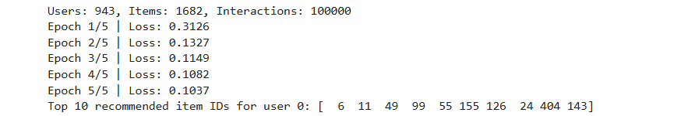
 | Experiment Title: Fully Convolutional Neural Networks.
 | Laboratory: DEEP LEARNING LAB
Experiment No: 8 | Department: | Semester:

Fully Convolutional Networks (FCNs) are a type of neural network where all layers are convolutional, replacing the fully connected layers found in traditional CNNs. This architecture makes them flexible, as they can process input images of any size and are primarily used for semantic segmentation by producing pixel-wise predictions. To achieve this, FCNs often use a combination of a down sampling path (for feature extraction), a 1x1 convolutional layer to adjust the number of output channels, and an up sampling path (using transposed convolution) to restore the spatial resolution of the output image.

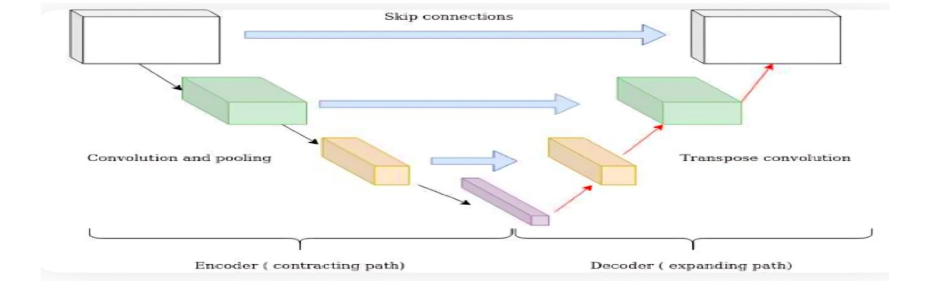
Figure 3 Fully convolutional network
PROGRAM
import torch
import torch.nn as nn
import torch.nn.functional as F
import numpy as np
import matplotlib.pyplot as plt
# Generate five synthetic digits/letters
def create_synthetic_digit(shape=(28,28), kind=0):
""kind: 0-4 for different synthetic patterns""
img = np.zeros(shape)
if kind == 0:
img[5:23, 12:16] = 1.0 # vertical bar
elif kind == 1:
img[12:16, 5:23] = 1.0 # horizontal bar
elif kind == 2:
img[5:23, 5:23] = np.eye(18) # diagonal
elif kind == 3:
img[8:20, 8:20] = 1.0 # square
elif kind == 4:
img[5:23, 8:20] = np.tril(np.ones((18,12))) # lower triangle
return img
images = [create_synthetic_digit(kind=i) for i in range(5)]
images_tensor = torch.tensor(images, dtype=torch.float32).unsqueeze(1) # shape [5,1,28,28]
#Define Fully Convolutional Network
class FCN(nn.Module):
def __init__(self):
super(FCN, self).__init__()
self.conv1 = nn.Conv2d(1, 16, kernel_size=3, padding=1)
self.conv2 = nn.Conv2d(16, 32, kernel_size=3, padding=1)
self.conv3 = nn.Conv2d(32, 1, kernel_size=3, padding=1) # output 1-channel map
def forward(self, x):
x = F.relu(self.conv1(x))
x = F.relu(self.conv2(x))
x = self.conv3(x) # 2D feature map output
return x
model = FCN()
#Forward pass for all images
outputs = model(images_tensor) # shape [5,1,28,28]
#Visualize input and output
fig, axes = plt.subplots(5, 2, figsize=(6,15))
for i in range(5):
axes[i,0].imshow(images[i], cmap='gray')
axes[i,0].set_title(f"Input {i}")
axes[i,0].axis('off')
axes[i,1].imshow(outputs[i,0].detach().numpy(), cmap='hot')
axes[i,1].set_title(f"FCN Output {i}")
axes[i,1].axis('off')
plt.tight_layout()
plt.show()
#Print shapes
print(f"Input batch shape: {images_tensor.shape}")
print(f"FCN output batch shape: {outputs.shape}")

OUTPUT
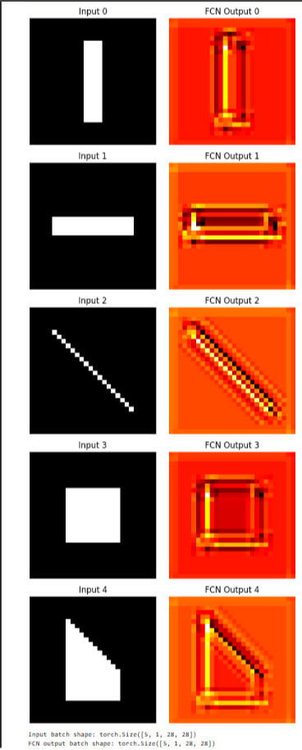
 | Experiment Title: ConvNets for Classification and Localization.
 | Laboratory: DEEP LEARNING LAB
Experiment No: 9 | Department: | Semester:

PROGRAM
#Setup
!pip install torch torchvision matplotlib -q
import torch
import torch.nn as nn
import torch.optim as optim
import torch.nn.functional as F
from torchvision import transforms, models
import matplotlib.pyplot as plt
import numpy as np
from PIL import Image, ImageDraw

device = 'cuda' if torch.cuda.is_available() else 'cpu'
print("Using device:", device)

#Model Definition (ResNet backbone)
class ResNetLocalization(nn.Module):
def __init__(self, num_classes=5):
super().__init__()
# Use pretrained ResNet18 as feature extractor
backbone = models.resnet18(weights=models.ResNet18_Weights.DEFAULT)
num_feats = backbone.fc.in_features
backbone.fc = nn.Identity() # remove classifier
self.backbone = backbone

# Classification head
self.class_head = nn.Sequential(
nn.Linear(num_feats, 256),
nn.ReLU(),
nn.Linear(256, num_classes)
)

# Bounding box regression head
self.bbox_head = nn.Sequential(
nn.Linear(num_feats, 256),
nn.ReLU(),
nn.Linear(256, 4), # (x, y, w, h)
nn.Sigmoid() # keep values 0–1
)
def forward(self, x):
feat = self.backbone(x)
cls_out = self.class_head(feat)
bbox_out = self.bbox_head(feat)
return cls_out, bbox_out

# Initialize Model and Dummy Data
num_classes = 5
class_names = ["dog", "cat", "car", "person", "bird"] # modify for your dataset

model = ResNetLocalization(num_classes).to(device)

criterion_class = nn.CrossEntropyLoss()
criterion_bbox = nn.SmoothL1Loss()
optimizer = optim.Adam(model.parameters(), lr=1e-4)

# Dummy batch (for demonstration)
images = torch.randn(8, 3, 224, 224).to(device)
labels = torch.randint(0, num_classes, (8,)).to(device)
bboxes = torch.rand(8, 4).to(device) # normalized 0–1

#Dummy Training Step (just demo)
model.train()
for epoch in range(3):
class_pred, bbox_pred = model(images)
loss_class = criterion_class(class_pred, labels)
loss_bbox = criterion_bbox(bbox_pred, bboxes)
loss = loss_class + 1.0 * loss_bbox

optimizer.zero_grad()
loss.backward()
optimizer.step()

print(f"Epoch {epoch+1}: ClassLoss={loss_class.item():.4f}, BoxLoss={loss_bbox.item():.4f}")

#Test on One Image + Visualization
model.eval()

# Download a test image
!wget -q https://upload.wikimedia.org/wikipedia/commons/9/9a/Pug_600.jpg -O test.jpg

img = Image.open("test.jpg").convert('RGB')
transform = transforms.Compose([
transforms.Resize((224, 224)),
transforms.ToTensor()
])
input_tensor = transform(img).unsqueeze(0).to(device)

# Predict
with torch.no_grad():
class_logits, bbox_pred = model(input_tensor)
probs = torch.softmax(class_logits, dim=1)
pred_class = torch.argmax(probs, dim=1).item()
pred_bbox = bbox_pred[0].cpu().numpy()
pred_class_name = class_names[pred_class]
print(f"\nPredicted class: {pred_class_name} (index {pred_class})")
print("Predicted box (x, y, w, h):", np.round(pred_bbox, 4))

# 6. Draw Bounding Box with Class Name
def draw_bbox(img, bbox, label=None):
draw = ImageDraw.Draw(img)
W, H = img.size
x, y, w, h = bbox
x1, y1 = int((x - w/2) * W), int((y - h/2) * H)
x2, y2 = int((x + w/2) * W), int((y + h/2) * H)
draw.rectangle([x1, y1, x2, y2], outline="red", width=3)
if label is not None:
draw.text((x1 + 5, y1 + 5), label, fill="red")
return img

img_boxed = draw_bbox(img.copy(), pred_bbox, pred_class_name)
plt.imshow(img_boxed)
plt.axis('off')
plt.show()

OUTPUT

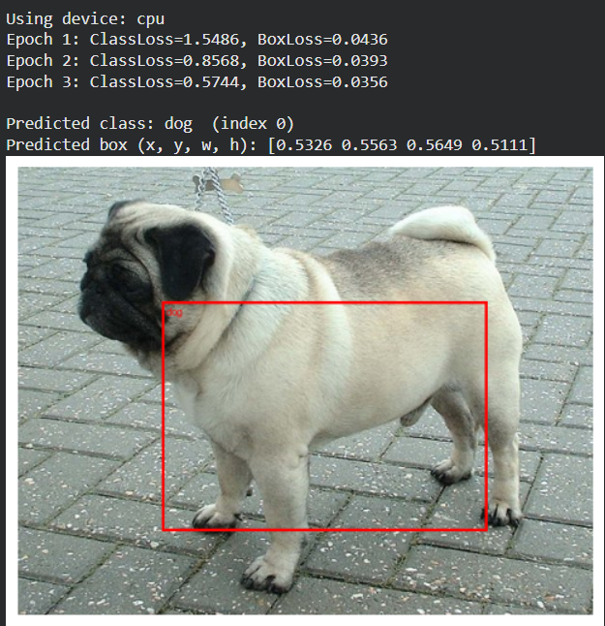

 | Experiment Title: Text Classification and Word Vectors.
 | Laboratory: DEEP LEARNING LAB
Experiment No: 10 | Department: | Semester:

PROGRAM

# Install dependencies
!pip install torch spacy requests -q
import torch
import torch.nn as nn
import torch.optim as optim
import spacy
import pandas as pd
import numpy as np
import requests, zipfile, io
device = torch.device('cuda' if torch.cuda.is_available() else 'cpu')
nlp = spacy.load("en_core_web_sm")

# Download GloVe embeddings
url = "http://nlp.stanford.edu/data/glove.6B.zip"
r = requests.get(url)
z = zipfile.ZipFile(io.BytesIO(r.content))
glove_file = z.open('glove.6B.100d.txt')
embeddings_index = {}
for line in glove_file:
values = line.decode('utf-8').split()
word = values[0]
coefs = np.array(values[1:], dtype='float32')
embeddings_index[word] = coefs
print("Loaded GloVe embeddings:", len(embeddings_index))

# Sample dataset
data = {
'text': [
"I love this car, it's fast and comfortable",
"The engine is terrible, waste of money",
"Amazing design and smooth ride",
"I hate this car, very noisy and uncomfortable",
"Excellent fuel efficiency and great handling",
"Worst car ever, keeps breaking down"
],
'label': ['positive', 'negative', 'positive', 'negative', 'positive', 'negative']
}
df = pd.DataFrame(data)
label_map = {'positive':0, 'negative':1}

# Convert text to average embedding
def text_to_avg_vector(text):
tokens = [tok.text.lower() for tok in nlp(text)]
vecs = [embeddings_index.get(tok, np.zeros(100)) for tok in tokens]
if len(vecs) == 0:
return torch.zeros(100)
return torch.tensor(np.mean(vecs, axis=0), dtype=torch.float)
X = torch.stack([text_to_avg_vector(t) for t in df['text']])
y = torch.tensor([label_map[l] for l in df['label']], dtype=torch.long)

# Simple Feed-Forward Model
class FFClassifier(nn.Module):
def __init__(self, input_dim, hidden_dim, output_dim):
super().__init__()
self.fc1 = nn.Linear(input_dim, hidden_dim)
self.relu = nn.ReLU()
self.fc2 = nn.Linear(hidden_dim, output_dim)
def forward(self, x):
x = self.fc1(x)
x = self.relu(x)
x = self.fc2(x)
return x
model = FFClassifier(input_dim=100, hidden_dim=32, output_dim=2).to(device)
criterion = nn.CrossEntropyLoss()
optimizer = optim.Adam(model.parameters(), lr=0.01)

# Training
X, y = X.to(device), y.to(device)
for epoch in range(20):
optimizer.zero_grad()
outputs = model(X)
loss = criterion(outputs, y)
loss.backward()
optimizer.step()
print(f"Epoch {epoch+1}, Loss={loss.item():.4f}")

# Predictions
model.eval()
with torch.no_grad():
outputs = model(X)
preds = torch.argmax(outputs, dim=1)
for i, text in enumerate(df['text']):
actual = df['label'][i]
predicted = [k for k,v in label_map.items() if v==preds[i].item()][0]
print(f"Text: '{text}' | Predicted: {predicted}, Actual: {actual}")

OUTPUT
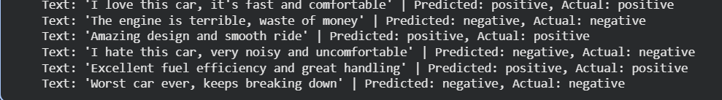

 | Experiment Title: Character Level Language Model.
 | Laboratory: DEEP LEARNING LAB
Experiment No: 11 | Department: | Semester:

PROGRAM
#Install PyTorch GPU version if not already installed
!pip install torch==2.1.0+cu118 --extra-index-url https://download.pytorch.org/whl/cu118

# Imports
import torch
import torch.nn as nn
import torch.optim as optim
import numpy as np

#Check device
device = torch.device("cuda" if torch.cuda.is_available() else "cpu")
print("Using device:", device)

#Example text about Virat Kohli (expandable)
text = """
Virat Kohli is one of the best cricketers in the world. He is known for his aggressive batting style and excellent leadership skills.
He has led India to many victories and holds numerous records in international cricket.
Kohli is also admired for his fitness and dedication to the game, making him a role model for aspiring cricketers.
His passion for the sport and consistency on the field have made him one of the most respected players globally.
"""
# Character mapping
chars = sorted(list(set(text)))
char2idx = {ch:i for i,ch in enumerate(chars)}
idx2char = {i:ch for i,ch in enumerate(chars)}
vocab_size = len(chars)
print("Vocab size:", vocab_size)
text_as_int = [char2idx[c] for c in text]

# Create sequences
seq_length = 40
step = 1
sequences = []
targets = []
for i in range(0, len(text_as_int) - seq_length, step):
sequences.append(text_as_int[i:i+seq_length])
targets.append(text_as_int[i+seq_length])
X = torch.tensor(sequences, dtype=torch.long).to(device)
y = torch.tensor(targets, dtype=torch.long).to(device)

#Character-level LSTM model
class CharLSTM(nn.Module):
def __init__(self, vocab_size, embed_dim, hidden_dim, num_layers=2):
super().__init__()
self.embedding = nn.Embedding(vocab_size, embed_dim)
self.lstm = nn.LSTM(embed_dim, hidden_dim, num_layers=num_layers, batch_first=True)
self.fc = nn.Linear(hidden_dim, vocab_size)
def forward(self, x, hidden=None):
x = self.embedding(x)
out, hidden = self.lstm(x, hidden)
out = self.fc(out[:, -1, :])
return out, hidden

#Initialize model
EMBED_DIM = 32
HIDDEN_DIM = 128
NUM_LAYERS = 2
model = CharLSTM(vocab_size, EMBED_DIM, HIDDEN_DIM, NUM_LAYERS).to(device)
criterion = nn.CrossEntropyLoss()
optimizer = optim.Adam(model.parameters(), lr=0.003)

#Training loop
N_EPOCHS = 50
BATCH_SIZE = 16
for epoch in range(1, N_EPOCHS+1):
model.train()
epoch_loss = 0
for i in range(0, len(X), BATCH_SIZE):
xb = X[i:i+BATCH_SIZE]
yb = y[i:i+BATCH_SIZE]
optimizer.zero_grad()
output, _ = model(xb)
loss = criterion(output, yb)
loss.backward()
optimizer.step()
epoch_loss += loss.item() * len(xb)
if epoch % 10 == 0:
print(f"Epoch {epoch}/{N_EPOCHS}, Loss: {epoch_loss/len(X):.4f}")

#Function to generate next word
def generate_next_word(model, start_str, temperature=0.8):
model.eval()
input_seq = torch.tensor([char2idx[c] for c in start_str], dtype=torch.long).unsqueeze(0).to(device)
hidden = None
generated = ""
while True:
output, hidden = model(input_seq, hidden)
probs = torch.softmax(output / temperature, dim=-1).detach().cpu().numpy().flatten()
next_idx = np.random.choice(len(probs), p=probs)
next_char = idx2char[next_idx]

# Skip starting spaces
if len(generated) == 0 and next_char == " ":
input_seq = torch.tensor([[next_idx]], dtype=torch.long).to(device)
continue

if next_char == " ":
break
generated += next_char
input_seq = torch.tensor([[next_idx]], dtype=torch.long).to(device)
return generated

#Function to generate multiple words
def generate_text(model, start_str, num_words=10):
current_text = start_str
for _ in range(num_words):
next_word = generate_next_word(model, current_text)
current_text += " " + next_word
return current_text

# Generate example
start_input = "Virat Kohli is"
generated_text = generate_text(model, start_input, num_words=10)
print("\nGenerated Text:\n", generated_text)
O

OUTPUT
